|  |
| --- |
| EPAM Systems, RD Dep. |
| MTN.BI.08 Transportation |

|  |  |  |  |  |  |
| --- | --- | --- | --- | --- | --- |
| REVISION HISTORY | | | | | |
| Ver. | Description of Change | Author | Date | Approved | |
| Name | Effective Date |
| 1.0 | Report on task | Olga Hilko | 05-DEC-2017 |  |  |

Contents

1. ETL Transportation - Analytical 3

1.1. Transportation Description 3

2. ETL Extraction – Example of Loading FCT_* 3

2.1. Prepare Table of Facts to SAL Layer 3

3. Transportable Tablespaces and DBLinks 3

4. Hierarchies 3

# Transportable Tablespaces

Create table spaces

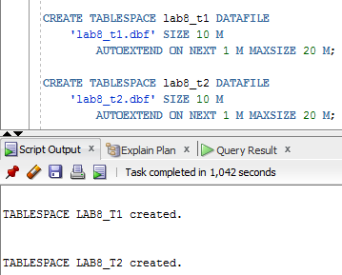

Create user for lab work

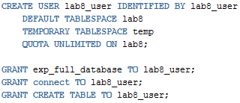

Create table under the lab8_user and check the table space with the help of creation script

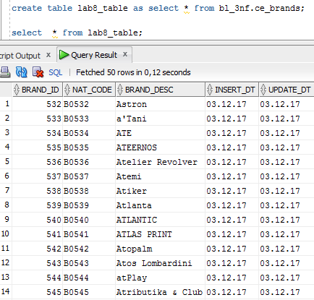

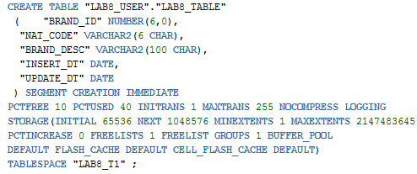

Check ability of table space transport and find out the restrictions / violations

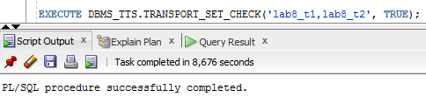

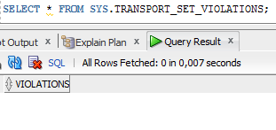

Drive table space into read only mode



Create directory for export and start export itself (expdp)



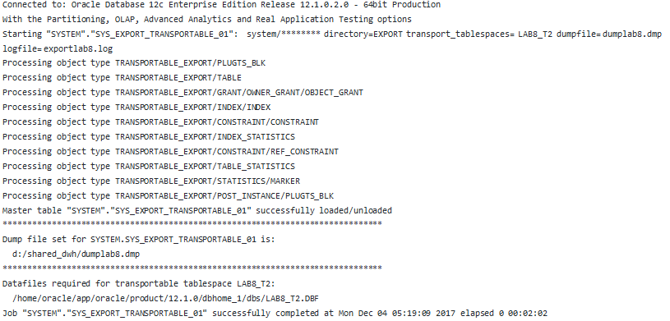

Then import the tablespace by the same example

# DB Link

Grant lab8_user to create DB links



Create DB link

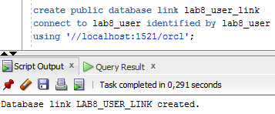

Check it

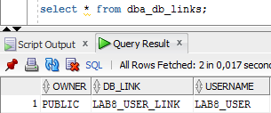

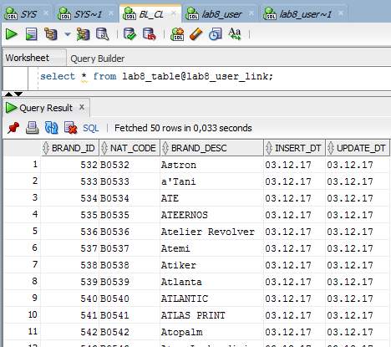

# Table Functions

Replace at least one cleansing (CLS) table with Oracle Table function.

## Create type

CREATE TYPE t_tf_row AS OBJECT (

id NUMBER,

description VARCHAR2(50)

);

/

## Create table function

CREATE TYPE t_tf_tab IS TABLE OF t_tf_row;

CREATE OR REPLACE FUNCTION get_tab_tf (p_rows IN NUMBER) RETURN t_tf_tab AS

l_tab t_tf_tab := t_tf_tab();

BEGIN

FOR i IN 1 .. p_rows LOOP

l_tab.extend;

l_tab(l_tab.last) := t_tf_row(i, 'Description for ' || i);

END LOOP;

RETURN l_tab;

END;

/

## Execution test

SELECT *

FROM TABLE(get_tab_tf(10))

ORDER BY id DESC;